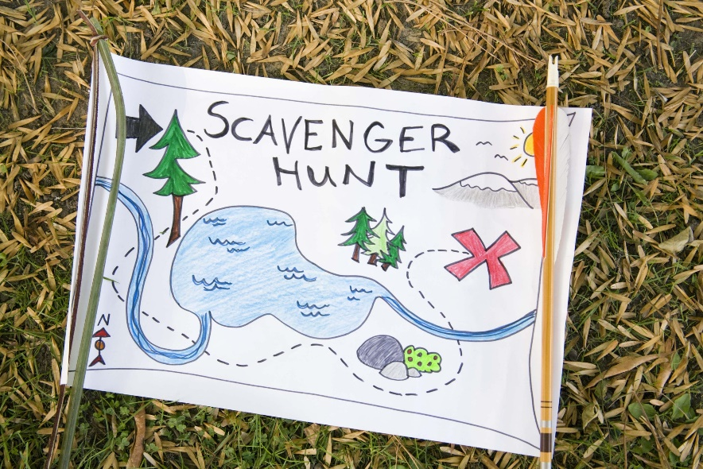 | GAME 1:  (signature + points)
GAME 2:
(signature + points)

INTO THE WILD SCAVENGER HUNT
​
Explore the school surroundings and find/collect the following items:
collect ​a flat rock/pebble
collect a round rock/stone
collect a heart-shaped stone
find a Zen Garden and take a group photo in a Yoga position
take a photo of an insect
collect a nice piece of wood (DO NOT damage any tree)
record the sound of nature
find a four-leaf clover
take a photo of a solar panel
take a photo of the clouds
take a nice photo of Monte Rosa without any buildings or constructions
find something red
collect a pine cone
take a photo of a picnic area
take a group photo of your team near a pond and a palm tree
create a bunch of colourful flowers
collect a bird's feather
take a photo of a push scooter
take a photo of a pomegranate
mimic a dangerous animal coming out of the forest (take a photo or video) and record a 30 sec documentary footage
Find all the GEOCACHES in the area and take a group photo with each of them

